
Glasgow Branch
May 2017 Newsletter

A warm welcome to our May newsletter! We hope you are enjoying the lighter mornings and longer days.

Fundraising

Some of you are taking advantage of the better weather by deciding to walk, run or cycle to raise money for SACHD. Glasgow member, Kate McKee is raising funds by having a party night on 9th June. Thank you Kate! A 9 year-old boy in Lancashire is aiming to raise £300 by taking part in his first ever triathlon event. Good luck Kristian!

Thanks to all who donate to SACHD. Your efforts help to provide equipment for use in hospitals and at homes. Your generosity helps to fund projects and clinics. Your kindness provides families with holiday breaks. Your faithful support means families can be brought together at social events - parties, days out, meet-ups and residential weekends. So, thank you!

If you wish to set up a fundraising page or to donate, consider using one of the following methods.

BT MyDonate; https://mydonate.bt.com/charities/scottishassociationforchildrenwithheartdisorders

JustGiving; https://www.justgiving.com/sachd

Virgin; http://m.virginmoneygiving.com/mt/uk.virginmoneygiving.com/charity-web/charity/finalCharityHomepage.action?charityId=1008788

It is worth repeating that BT MyDonate has the added advantage of being commission free- SACHD pays no charge for funds raised by donors.

If you would like to share how you've been fundraising for the charity please get in touch.

Recent gatherings

Glasgow Branch AGM
We held our annual AGM on Thursday 20th April.

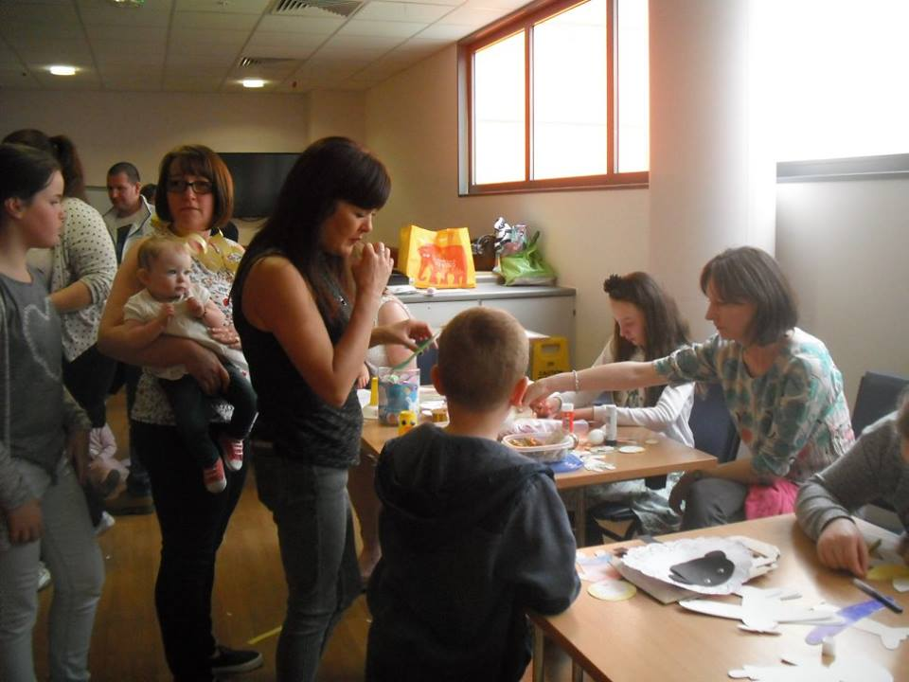
Easter
Our Easter Event on Sunday 9th April had a bumper turnout. A busy day with lots of innovative crafting and cake decorating. It was great to welcome some new families and inpatients along and to have the support of Carla, Cardiac Liaison coordinator. We are grateful to IpDip Theatre Company for bringing their interactive, sensory performance Head in the Clouds for us to enjoy.

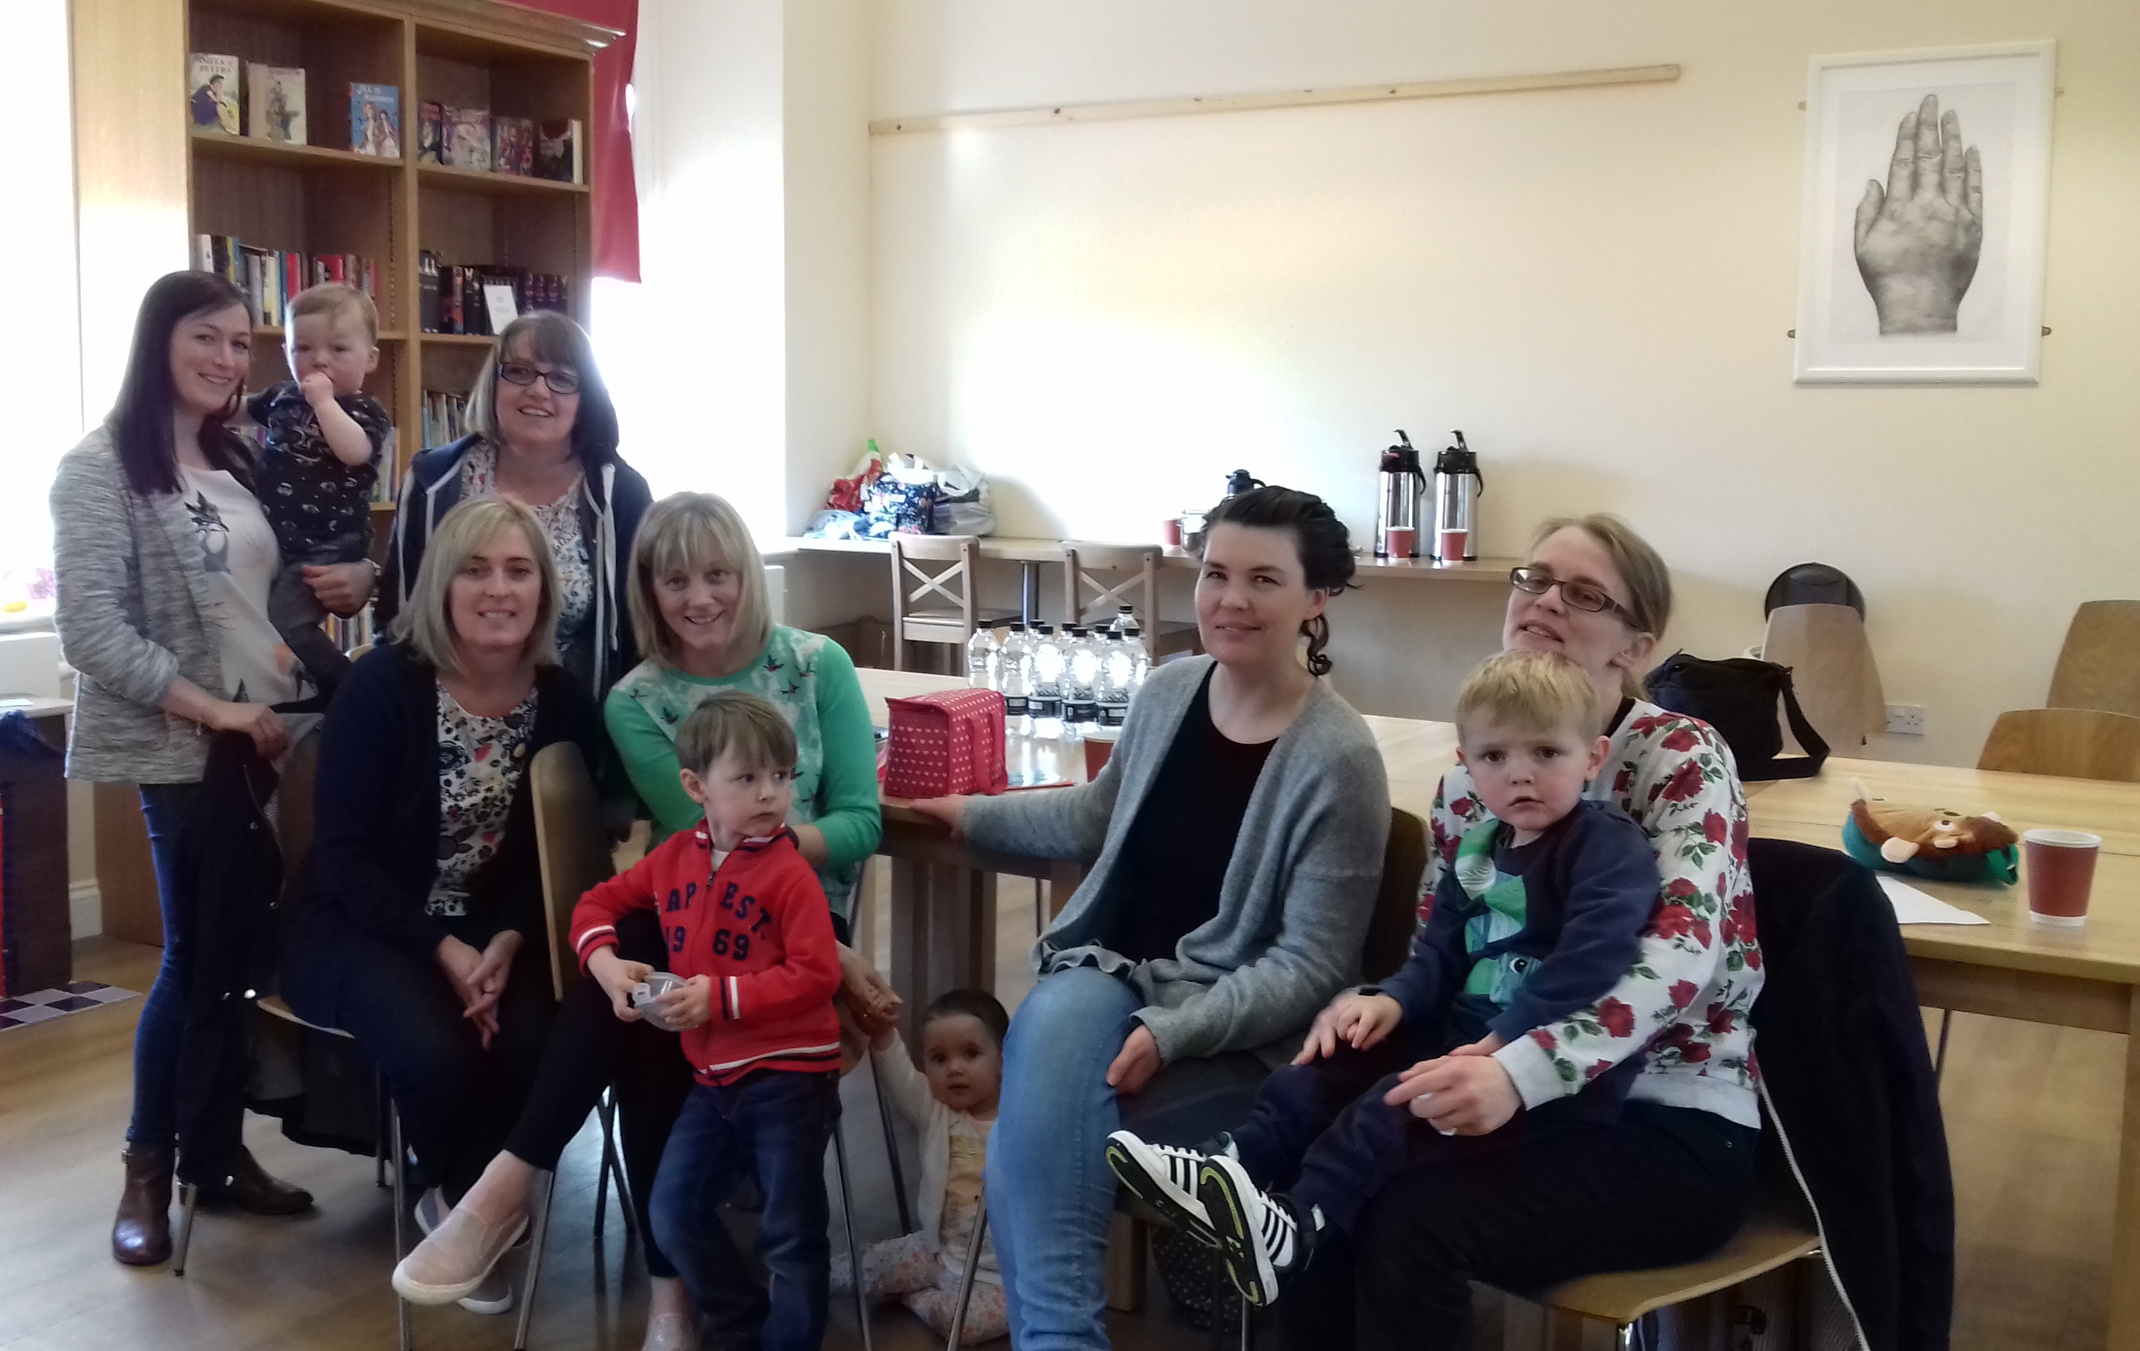

Kilmarnock
We had our first meet-up at the Killie Browser in Kilmarnock. It was nice for both the children and the adults to socialise away from the hospital in a relaxing environment.

Coming up

Family Weekend
The residential SACHD Family Weekend takes place next weekend in Pitlochry. Well done to Glasgow Branch committee members, Caroline and Lesley for all their hard work in organising the weekend. To all those attending, we hope you have a wonderful time!

Sponsored Cycle & Fun Day, Millport - Saturday 3rd June
Time: 9:30 - 17:00
Join us at Largs pier at 9.30am on the 3rd June for our annual sponsored cycle around the Isle of Cumbrae. When you finish meet at the Tavern bring your picnic and have fun with everyone. You can spend the rest of the day exploring Millport, let the children have a go at the crazy golf on the front, have coffee or tea before you catch the bus and ferry back to Largs. Cost for a family is £12, this includes ferry, bike hire and a free go at crazy golf for the children.

Glasgow Science Centre – Sunday 11th June
Sunday 11th June. Free admission to the science centre for all our families. We need to book ahead. Please contact Lesley/Caroline to register your interest.

The 2017 Scottish AGM, Perth – 24th June
The 2017 Scottish AGM will be held in the Queens Hotel, Perth on the 24th June 2017. Further details will be published on the website as they become available.

Heads of Ayr Farm Park, Alloway by Ayr - Wednesday 12th July
Save the date! Further details in the next newsletter.

Almond Valley Heritage Centre, Livingston - Thursday 10th Aug
Save the date! Further details in the next newsletter.

Glasgow Branch Evening Meeting, Royal Hospital for Children – Tuesday 22nd August
All welcome as usual.
Support

We are making efforts to reach and support families outwith the Glasgow area acknowledging that social contact can be valuable when facing the difficulties associated with congenital heart disease however we appreciate that some of you are more remotely placed and cannot attend so please know that we are also, as always, available to talk via telephone or email. Our contacts appear at the foot of the page.

Deadline for your say on DLA

In our last newsletter we wrote about the success of a national campaign resulting in guidance on CHD now being available for DWP assessors. We also told you about an invitation to recent users of the service to join an experience panel and have a say as responsibility for certain benefits (including DLA) transfers to the Scottish Government. Registration is still open, until 12th May and details are available here;

http://www.gov.scot/Topics/People/fairerscotland/Social-Security/Experience-Panels

Best wishes from your Glasgow Branch Committee.

Glasgow branch contacts:

Chair: Lesley Kinnear Lkinnear@sky com
Assistant Chair: Caroline Aitken carolineaitken@googlemail.com
Treasurer: John Fegan john.fegan251@btinternet.com
Secretary: Joelle Miller glasgow@youngheart.info or millerjoelle@hotmail.com
Assistant Secretary: Anna Wilson mrsannawilson@gmail.com

And you can always get in touch with us via the SACHD Facebook page: https://www.facebook.com/TheSACHD/

